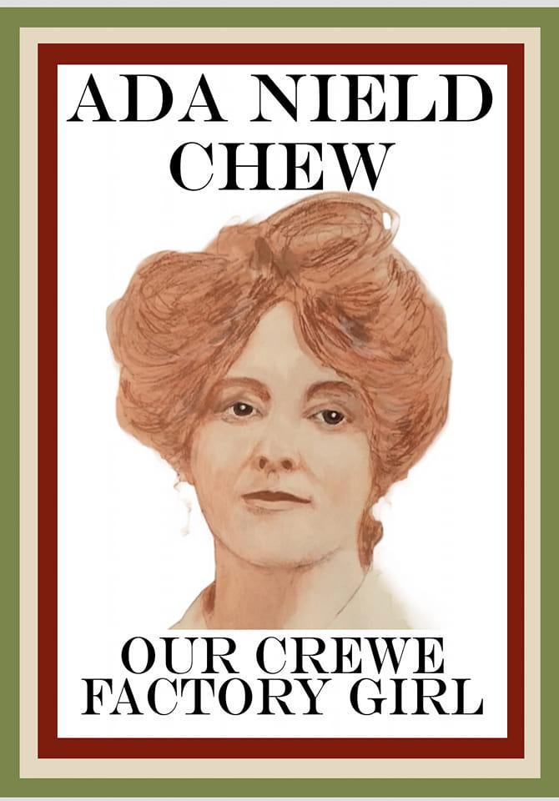

Sponsorship Form

| First Name: |  |
| --- | --- |
| Last Name: |  |
| Address:  County: |  |
| Post Code: |  |
| Email Address: |  |
| Telephone Number: |  |
| Name of Event: |  |

| Date |  |
| --- | --- |

| Title | Initial | Surname | Full Home Address | Post Code | Amount | More details | Date Paid |
| --- | --- | --- | --- | --- | --- | --- | --- |
|  |  |  |  |  |  |  |  |
|  |  |  |  |  |  |  |  |
|  |  |  |  |  |  |  |  |
|  |  |  |  |  |  |  |  |
|  |  |  |  |  |  |  |  |
|  |  |  |  |  |  |  |  |
|  |  |  |  |  |  |  |  |
|  |  |  |  |  |  |  |  |
|  |  |  |  |  |  |  |  |
|  |  |  |  |  |  |  |  |
|  |  |  |  |  |  |  |  |
|  |  |  |  |  |  |  |  |
|  |  |  |  |  |  |  |  |
|  |  |  |  |  |  |  |  |

| Information for donors  • Please ensure you fill out each section in full  • Please ensure the details of each donation are recorded accurately |
| --- |

| **HOW TO RETURN YOUR SPONSORSHIP MONEY**  Whether you choose to send your sponsorship to us  online, via the post or via bank transfer, it's quick and easy, • By post with a cheque made payable to  A statue for Ada to: 54-56 Beech Drive, Wistaston, Crewe, CW2 8RG (registered office)  • By bank transfer to lloyds Bank  A statue for Ada Sort code: 30-99-50  Account number: 76391568 |
| --- |